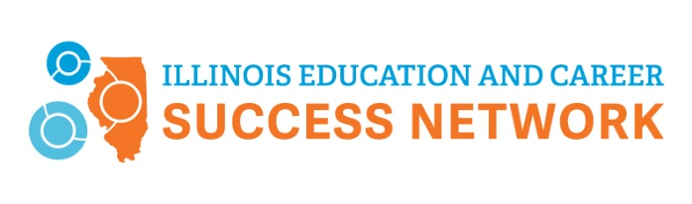

LEADERSHIP COMMUNITY APPLICATION

The Illinois Education and Career Success Network invites your community to seek designation as a Leadership Community. Communities may apply at any time by submitting their completed application to Director Edith Njuguna at enjuguna@niu.edu. The network’s organizers can support communities as needed to develop a plan, including helping to coordinate partners, reviewing data, and identifying goals.

Application Process
To apply, communities must outline a plan of action for working with partners to achieve local education and career outcome goals. The plan serves as the application and must address the following nine sections:
1. Define your community’s region (i.e., geographic area the community plan will cover).

2. Identify (or outline the process to identify) 3-5 ways you will measure success, including a timeline. (The metrics may be from the Success Network Dashboard at dashboard.ILSuccessNetwork.org or other sources. Metrics other communities have chosen include FAFSA completion, high school graduation, postsecondary remediation rates, etc.)

3. Identify (or outline the process to identify) key activities that will commence implementation during the next 12- to 24-month period for increasing college and career readiness and postsecondary attainment. Please briefly describe these strategies, which can be similar to the activities outlined in this plan or others you identify.

4. Identify (or describe your plan to identify) 3-4 priority workforce development and career areas based on the College and Career Pathway Endorsement’s sector areas: Agriculture, Food, and Natural Resources; Arts & Communication; Finance & Business Services; Health Sciences & Technology; Human and Public Services (including Education); Information Technology; Manufacturing, Engineering, Technology & Trades.

5. Describe how the activities identified will be intentionally designed to eliminate disparities in educational access and outcomes for students from historically underserved and underrepresented populations.

6. Describe the strategies you currently use or will use to engage individuals or groups that will be impacted by the decisions or activities of your collaborative when deciding which efforts to focus on to achieve equitable postsecondary attainment goals.

7. Identify a partner who will serve as a trusted intermediary organization to build a common agenda, articulate mutually reinforcing activities, measurements, and communications across sectors involving PreK-12 education, postsecondary education, employers, and civic community. Examples of intermediary organizations include community-based organizations, Regional Offices of Education, Education for Employment system offices, chambers of commerce, local Economic Development Councils, and existing collective impact leads.

8. Formally document your partnership with a Memoranda of Understanding (MOU) on all the above goals and activities involving all the following stakeholders:
  - Employers
  - Secondary education partners
  - Postsecondary education partners, specifically including the area community college
  - Municipal leaders
  - Representatives from community-based organizations
  - Elementary and/or early childhood education partners (optional but highly encouraged)
Attach all MOUs to the plan.

9. Describe your plan to engage additional community partners as the work evolves over time.

